IIHT Training (Hyderabad)

Stock Exchange Charting

Submitted by:

Adeeba Fatima

Date : 8.Aug.2019

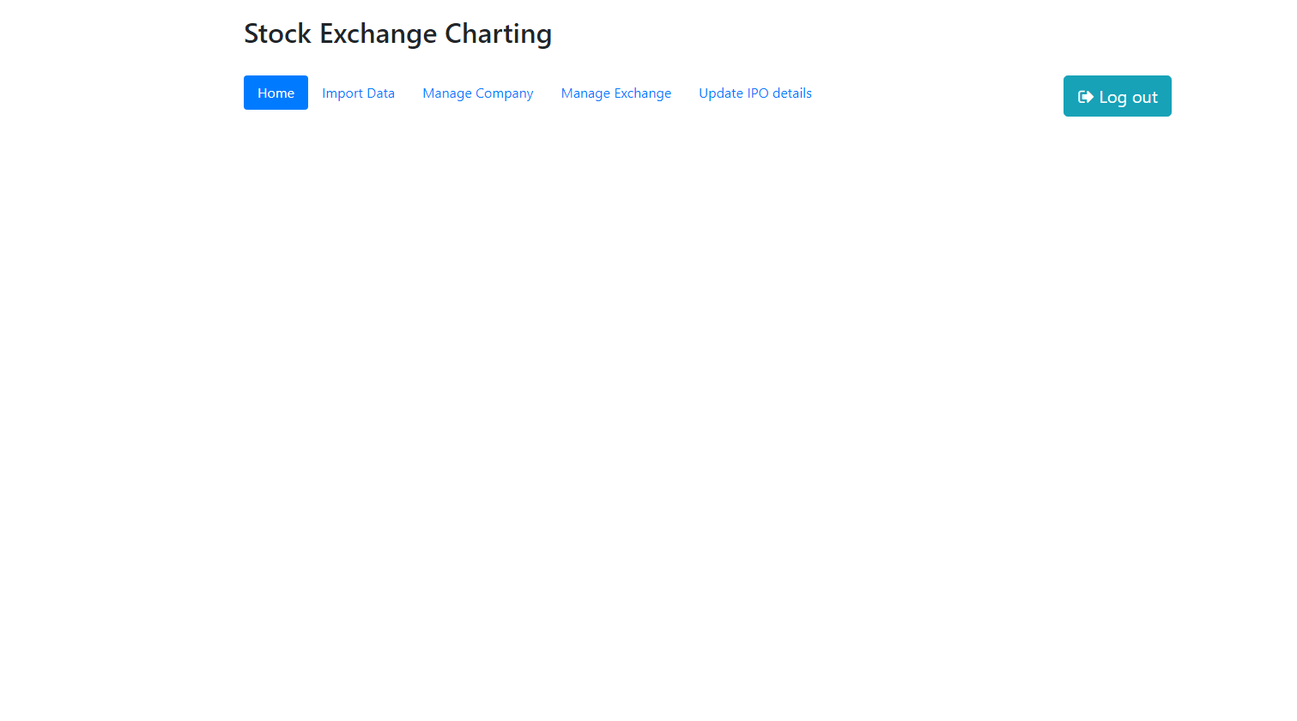Admin Landing Page

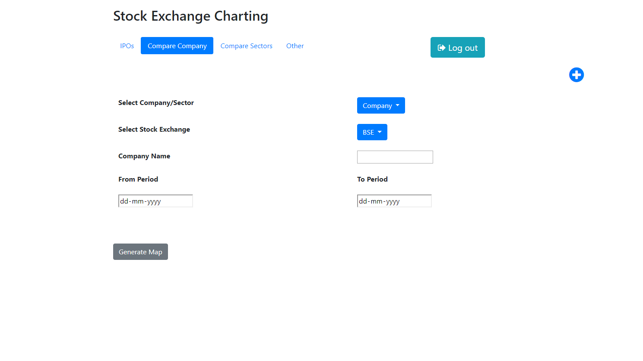Comparison Charts Page

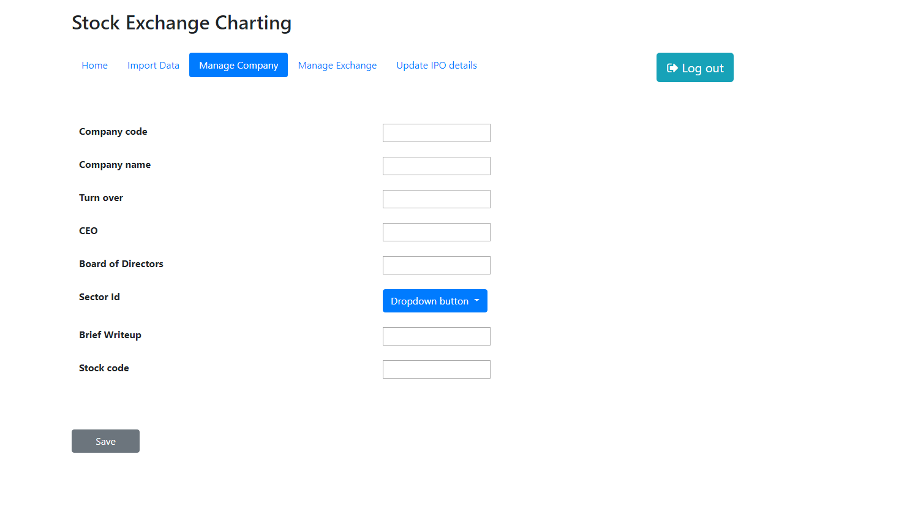Create a new Company Page

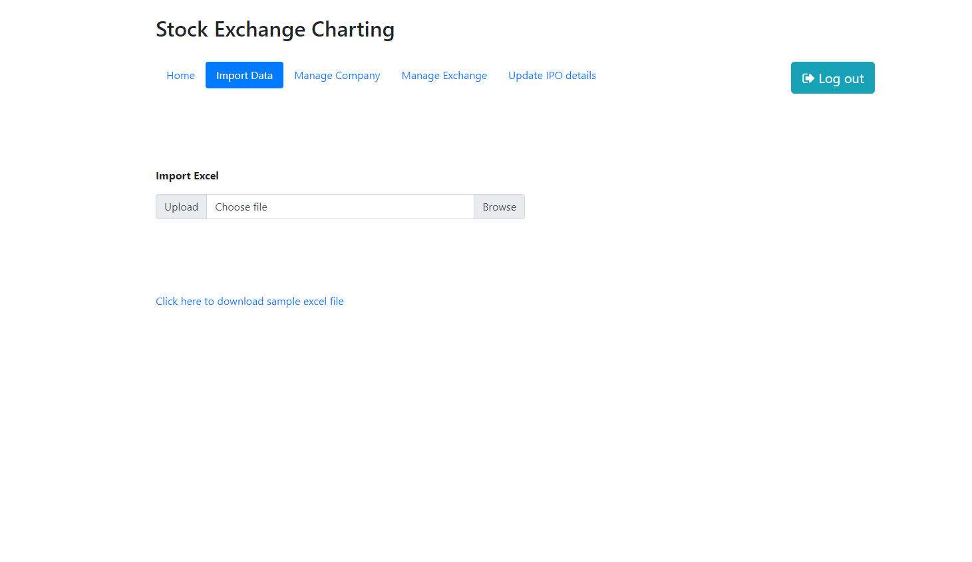Import Data Page

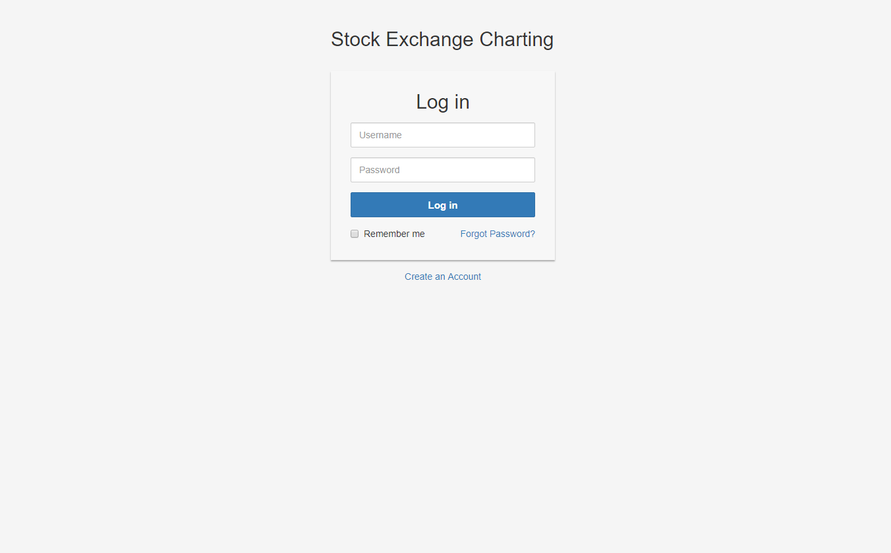

Login Page

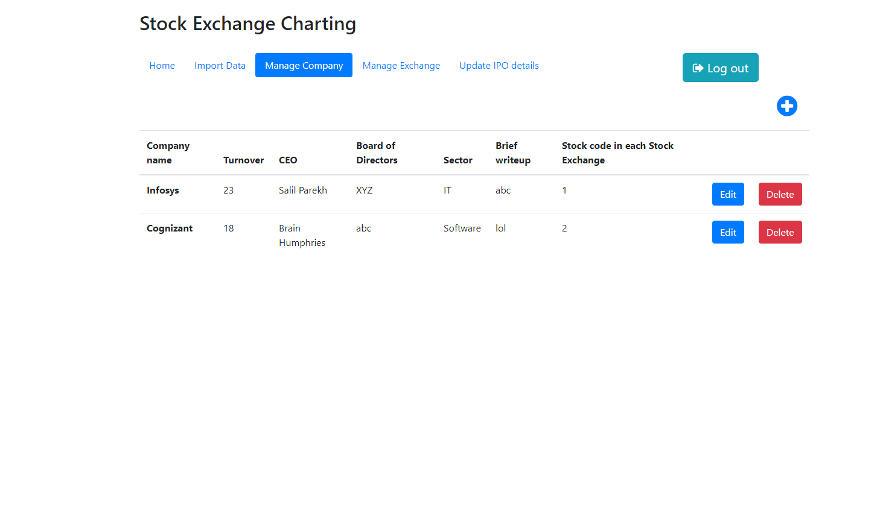Manage Companies Page

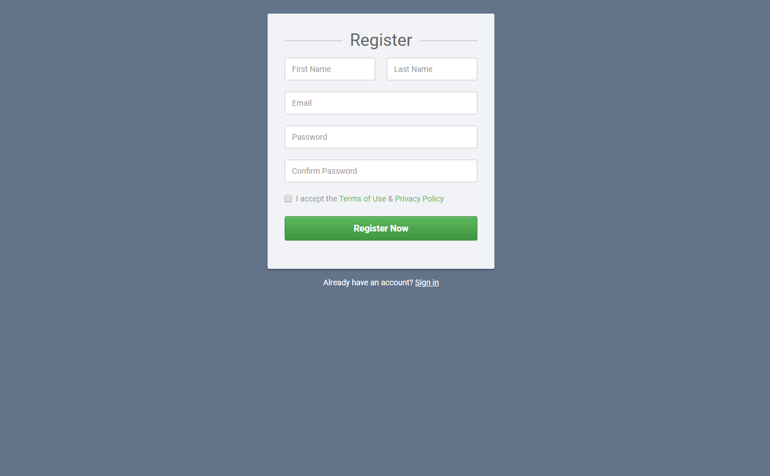Registration page

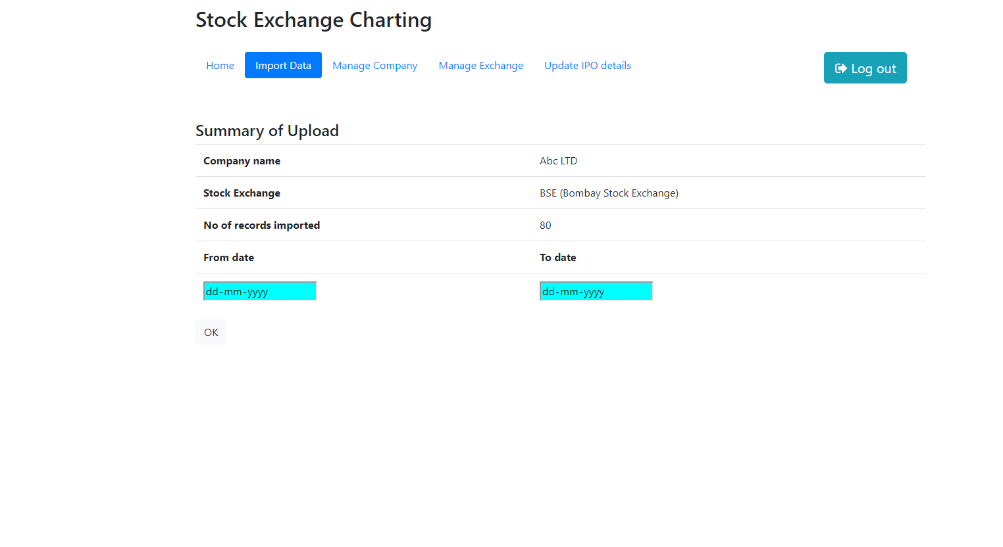Summary Page

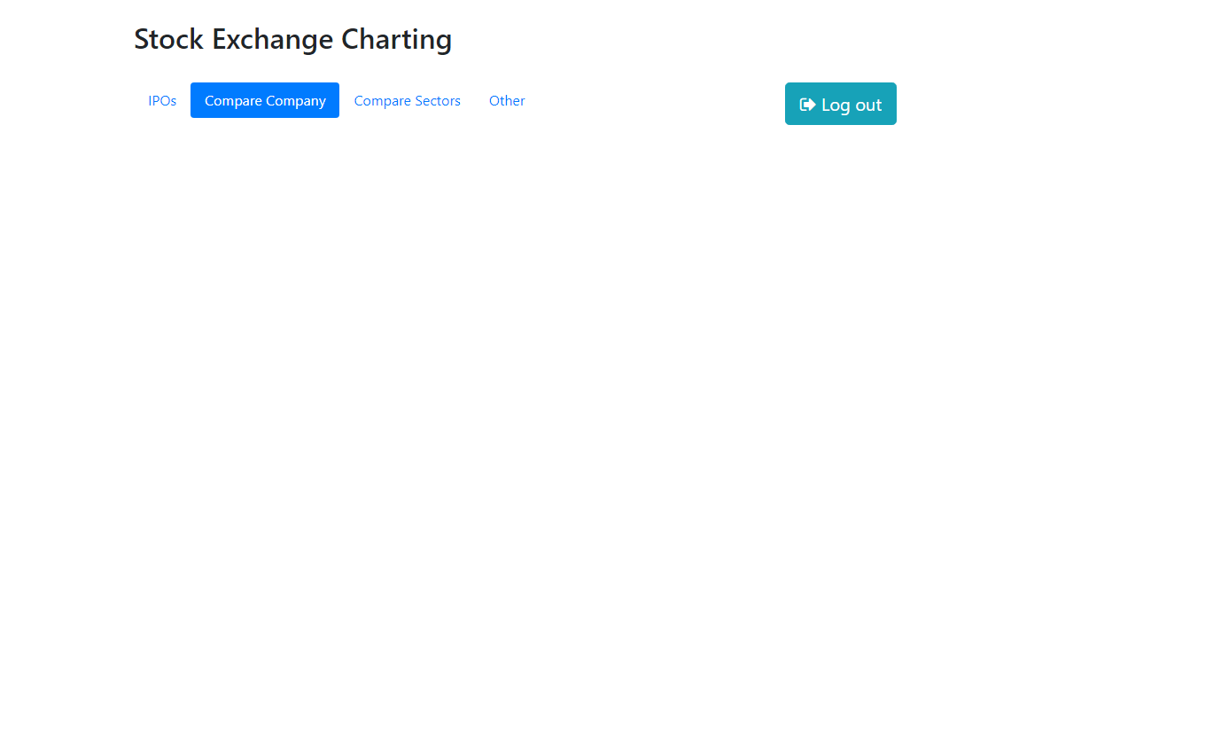User Landing Page

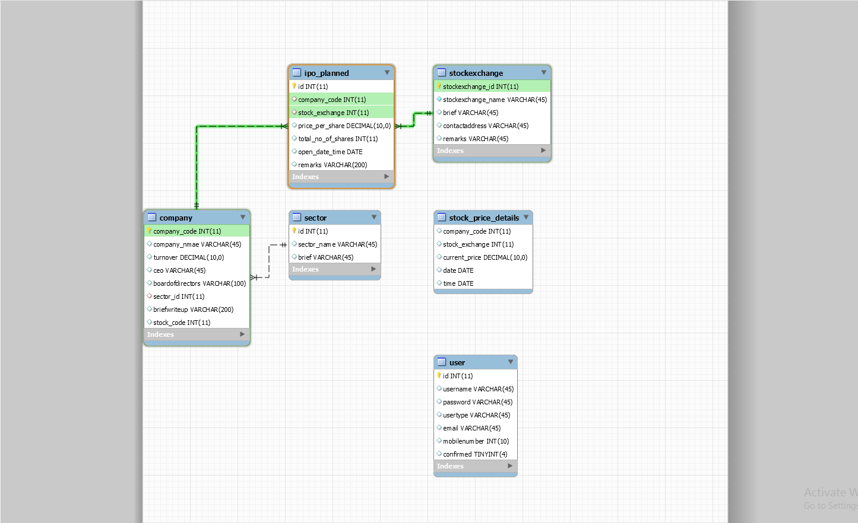

Reference:

https://github.com/Adeeba-Fatima/StockExchange.git